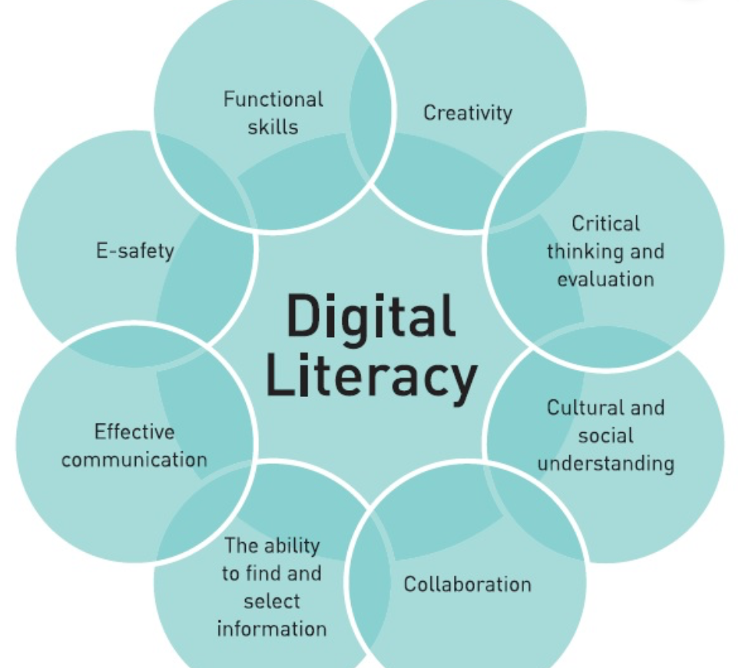

DIGITAL LITERACY
Project

Name: SARTHAK KHANDELWAL
Registration no.: 25BCE10228
CSE [CORE] – 1st yr
Course code: CSE-0001
30TH MARCH 2026

Introduction
As a Student Digital Ambassador, this project is undertaken with the aim of promoting digital literacy and responsible online behaviour among fellow students. In the present technology-driven environment, individuals frequently interact with various digital platforms; however, a comprehensive understanding of their effective, ethical, and secure usage is often lacking. This project is centred on the development of a comprehensive Digital Literacy Portfolio that demonstrates key competencies such as building a professional online presence, utilising digital tools efficiently, and maintaining proper online communication practices.
The project is organised into five distinct tasks, each addressing a crucial aspect of digital literacy, including awareness creation, portfolio development, platform exploration, email etiquette, and cybercrime prevention. Through this initiative, the project aspires to enhance digital awareness and equip students with essential skills required for academic and professional success.

Task 1: Create a Digital Literacy Awareness Infographic
For this task, I used Canva to create an infographic. Canva is an easy-to-use design tool that provides templates, icons, and layouts for creating visually appealing content.
My infographic covers three important topics: what digital literacy is, useful digital tools for students, and safe internet practices. I explained digital literacy as the ability to use technology effectively and responsibly. I also included examples of useful tools such as Google Docs, Zoom, and educational websites that help students in learning. Additionally, I highlighted safe internet practices like using strong passwords, avoiding suspicious links, and protecting personal information.
While creating the design, I focused on making the content simple, clear, and visually attractive by using icons, colors, and short points. One thing I found interesting was how easily Canva allows customization and creative design. However, I found it slightly difficult to choose the right layout and arrange all the information neatly in one infographic.
Overall, this task helped me improve my creativity and understanding of digital literacy concepts.

Task 2: Build your Student Digital Portfolio
For this task, I created accounts on three platforms: GitHub, LinkedIn, and ResearchGate. Each platform has a unique purpose and is useful for my academic and professional development.
GitHub is mainly used for coding and project sharing. It helps developers store, manage, and collaborate on code. I plan to use GitHub over the next four years to upload my projects, improve my programming skills, and build a strong portfolio.
LinkedIn is a professional networking platform where people connect with others, share achievements, and explore job opportunities. I will use LinkedIn to build my professional profile, connect with industry experts, and stay updated about internships and career opportunities.
ResearchGate is a platform for students and researchers to share and explore research work. It helps in gaining knowledge from academic papers and connecting with researchers. In the coming years, I plan to use it to read research papers and, if possible, share my own work.
Overall, these platforms will help me learn, grow, and prepare for my future career.

Task 3: Explore Coding & Collaboration Platforms
For this task, I used HackerRank for coding practice and Google Forms for collaboration. These platforms helped me improve both technical and digital communication skills.
In Part A, I created an account on HackerRank and completed a beginner-level challenge. This platform is used for practicing programming skills and improving problem-solving abilities. By solving the challenge, I learned basic coding concepts and understood how to write logical solutions. I plan to continue using HackerRank over the next few years to strengthen my coding skills and prepare for technical interviews.
In Part B, I created a Google Form titled “Digital Literacy Awareness Quiz” with five simple questions, including multiple choice and short answer types. Google Forms is useful for collecting responses and sharing information easily. I also viewed responses through Google Sheets, which helps in organizing and analyzing data.
Overall, these tools helped me develop coding practice, digital literacy awareness, and collaboration skills. They will support my academic growth and prepare me for future career opportunities.

Task 4: Professional Email & Etiquette Guide
In this task, I learned about professional email writing and responsible social media usage. I wrote two professional emails—one to a professor requesting an assignment extension and another to an internship coordinator expressing interest in a summer internship. This helped me understand the importance of clear subject lines, polite language, and proper structure in emails.
I also created a checklist of social media do’s and don’ts, which highlighted safe and responsible online behavior. It included practices like protecting personal information and avoiding harmful content.
A situation where poor digital communication caused a problem is when a student sent an unclear and informal email to a professor and did not receive a response on time. This could have been avoided by writing a clear and professional email. This task showed me the importance of good digital communication skills in daily life.

Task 5: Cybercrime Awareness
For this case study, I chose phishing as the type of cybercrime. Phishing is a fraud where attackers try to trick people into sharing sensitive information like passwords, bank details, or OTPs by pretending to be a trusted source.
Phishing usually happens in a few steps. First, the attacker sends a fake email, message, or link that looks genuine, such as from a bank or popular website. Next, the victim clicks the link and is taken to a fake website that looks real. Then, the victim enters personal details like login credentials or card information. Finally, the attacker uses this information to steal money or access accounts.
Phishing commonly targets students, working professionals, and people who are not aware of online scams. The consequences can be serious, including financial loss, identity theft, and loss of personal data. It can also cause stress and damage trust in online systems.
This case study helped me understand how important it is to verify links, avoid sharing sensitive information, and stay alert while using the internet. Awareness is the best way to prevent such cybercrimes.
While researching cybercrime and online safety, I was most surprised by how easily people fall victim to phishing and online payment fraud. Many scams look very real, making it difficult to identify them. I learned that even a small mistake, like clicking on an unknown link, can lead to serious problems.
Creating the prevention checklist helped me understand simple steps to stay safe online, especially while using UPI and digital payments. Awareness about official reporting channels like the National Cyber Crime Portal and helpline 1930 is also very important.
As a result of this task, one habit I will change is being more careful before clicking on any link or sharing personal information online. I will always verify sources and think twice before taking any action on the internet.

Conclusion
While researching cybercrime and online safety, I was most surprised by how easily people fall victim to phishing and online payment fraud. Many scams look very real, making it difficult to identify them. I learned that even a small mistake, like clicking on an unknown link, can lead to serious problems.
Creating the prevention checklist helped me understand simple steps to stay safe online, especially while using UPI and digital payments. Awareness about official reporting channels like the National Cyber Crime Portal and helpline 1930 is also very important.
As a result of this task, one habit I will change is being more careful before clicking on any link or sharing personal information online. I will always verify sources and think twice before taking any action on the internet.

REFRENCES:
Canva.com
github.com
linkedin.com
hackerrank.com
codechef.com
forms.google.com
cybercrime.gov.in
Cyber Crime Helpline 1930 (24x7 phone)

